ST.XAVIER’S COLLEGE

(Affiliated to Tribhuvan University)

Maitighar, Kathmandu



**Database Management System**

**Lab Assignment #1**

**Submitted By**

Tisa Maharjan

2nd Year/4th Sem

017BSCIT046

|  |  |
| --- | --- |
| **Submitted To:** |  |

|  |  |  |
| --- | --- | --- |
|  | **Signature** | **Remarks** |
| **Er. Sarjan Shrestha**  **Lecturer, Dept. of Computer Science** |  |  |

# Objective:

## To familiarize with Structured Query Language DDL statements and Data Types.

# Theory:

**DDL(Data Definition Language) :**DDL or Data Definition Language actually consists of the SQL commands that can be used to define the database schema. It simply deals with descriptions of the database schema and is used to create and modify the structure of database objects in database.

**DDL commands we use in this lab:**

* **CREATE** – is used to create the database or its objects (like table, index, function, views, store procedure and triggers).
* **DROP** – is used to delete objects from the database.
* **ALTER**-is used to alter the structure of the database.

**SQL Constraints**

SQL Constraints are rules used to limit the type of data that can go into a table, to maintain the accuracy and integrity of the data inside table. Constraints are used to make sure that the integrity of data is maintained in the database. Following are the most used constraints that can be applied to a table.

* **NOT NULL**
* **UNIQUE**
* **PRIMARY KEY**
* **FOREIGN KEY**
* **CHECK**
* **DEFAULT**
* **Data Type**

Data type in a database defines the field within database. Data type is a data storage format that can contain specific type or range of values.

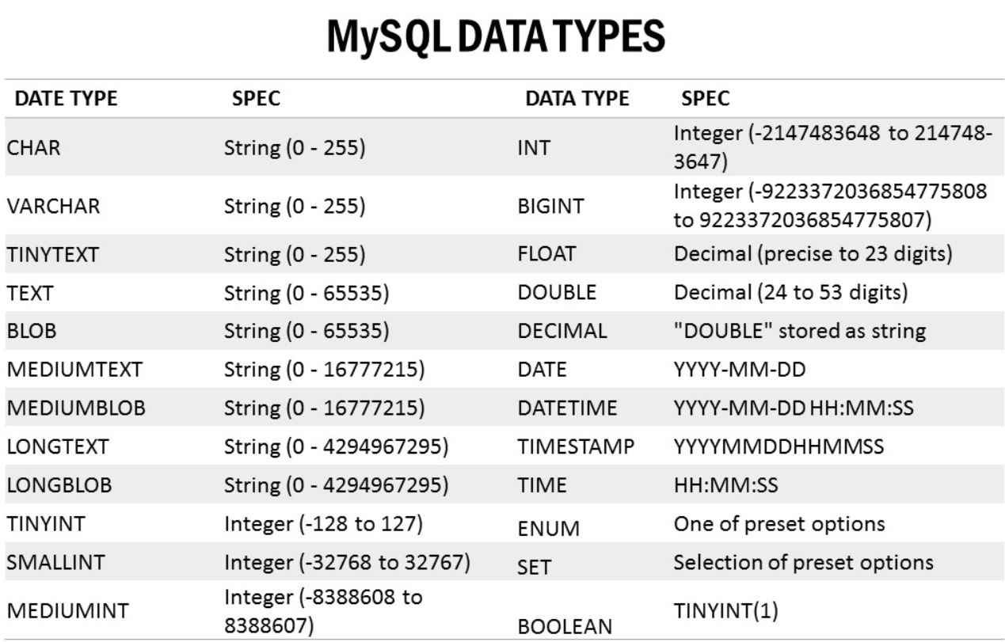

### Statement 1:

### Create a table “Employee” in database “SXC” with following attributes:

### EID INT

### FirstName VARCHAR (15)

### LastName VARCHAR (15)

### DeptId SMALLINT

### DOB DATE

## source code:

create database if not exists SXC;

use SXC;

create table if not exists employee(eid int, firstname varchar(15), lastname varchar(15), deptid smallint, dob date)engine = INNODB;

show tables;

desc employee;

## output:

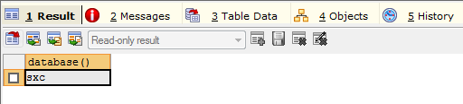

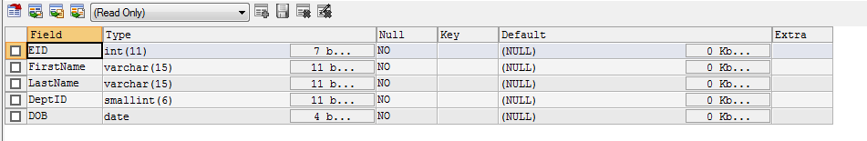

## statement 2:

### **ADD ATTRIBUTES “CONTACTNO” BIGINT , “EMAIL” VARCHAR(30), “SALARY” DECIMAL(10,2) IN A TABLE EMPLOYEE.**

## Source Code:

alter table employee

add column (

contactno bigint not null,

email varchar(30) not null,

salary decimal(10,2) not null

);

desc employee;

## output:

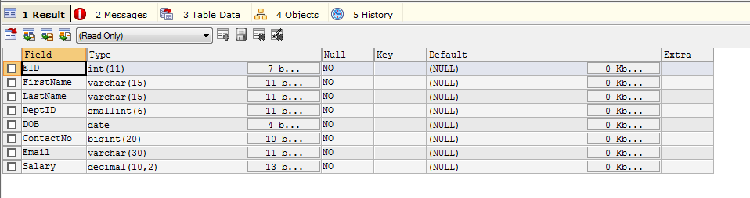

## statement 3:

### Drop an attribute “DOB” from Employee table.

## Source code:

alter table employee

drop column DOB;

desc employee;

## output:

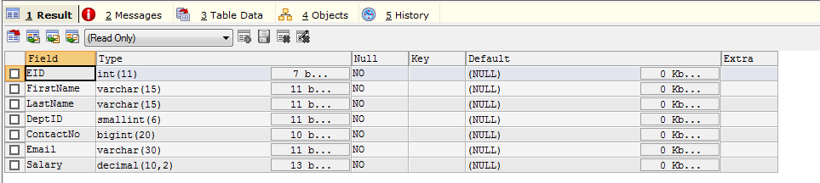

## statement 4:

### Create a table “Department” in database “SXC” WITH following attributes with not null constraint for all attributes and primary key constraint on ‘DID’:

### DID SMALLINT

### DName VARCHAR (20)

### Email VARCHAR (20)

## Source code:

create table department(

DID SMALLINT primary key,

DName VARCHAR(20) not null,

Email VARCHAR(20) not null

);

show tables;

desc department;

## output:

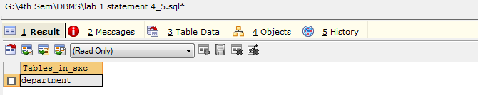

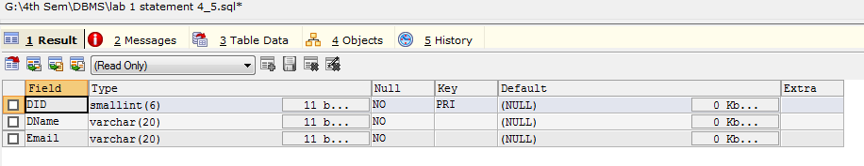

## statement 5:

### Add Primary Key constraint to Employee table EID, foreign key constraint on attribute DeptId that references table Department for attribute “DID”.

## Source code:

alter table employee

    add constraint primary key(eid);

alter table employee

    ADD constraint fkey FOREIGN KEY(deptid) REFERENCES department(did);

## output:



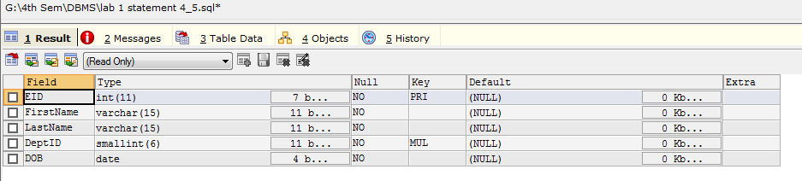

## statement 6:

### Create tables “Customer” and “Orders” with respective attributes with at least primary key constraints on both of tables. Referential key constraint should be defined such that given customer can have multiple orders but given order can only belong to one customer.

## Source code:

create table customer(

cust_id smallint primary key not null,

cust_name varchar(20),

contact_no bigint

);

desc customer;

create table orders(

order_id smallint primary key not null,

good_name varchar(15),

cust_id smallint,

foreign key(cust_id) references customer(cust_id)

);

desc orders;

## Output:

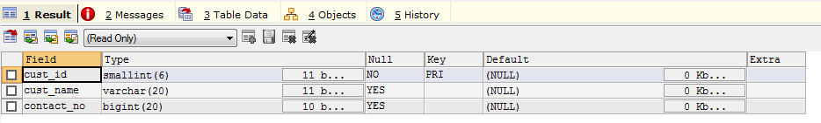

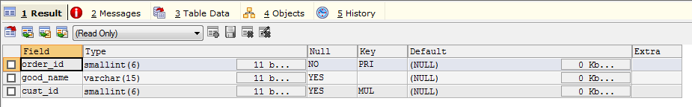

## Conclusion:

In this way, familiarization with Structured Query Language DDL statements and Data Types is done performing the above mentioned objective.